Status Code of Server Response

🔹 What is a Status Code in a Server Response?
# Source: Chatgpt (GPT-5-Mini) at [1/16/2026]
A status code is a 3-digit number included in the server's response to let the client know what happened when the server tried to handle the request.
It helps the client understand if the request was successful, failed, or needs action.

✅ Common Categories of Status Codes:
# Source: Chatgpt (GPT-5-Mini) at [1/16/2026]
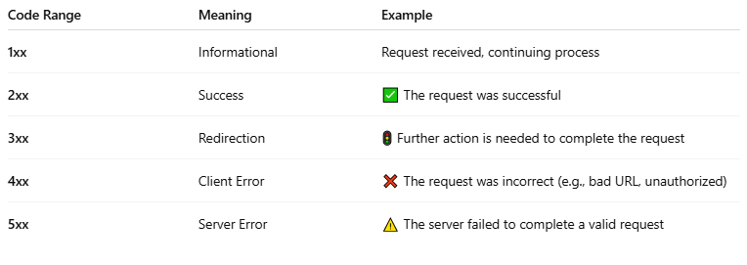
Code Range | Meaning | Example
1xx | Informational | Request received, continuing process
2xx | Success | ✅ The request was successful
3xx | Redirection | 🚦 Further action is needed to complete the request
4xx | Client Error | ❌ The request was incorrect (e.g., bad URL, unauthorized)
5xx | Server Error | ⚠️ The server failed to complete a valid request

✅ Common Status Codes:
# Source: Chatgpt (GPT-5-Mini) at [1/16/2026]
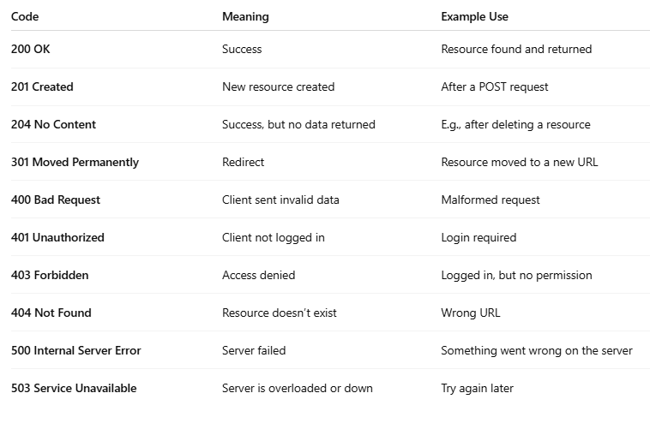
Code | Meaning | Example Use
200 OK | Success | Resource found and returned
201 Created | New resource created | After a POST request
204 No Content | Success, but no data returned | E.g., after deleting a resource
301 Moved Permanently | Redirect | Resource moved to a new URL
400 Bad Request | Client sent invalid data | Malformed request
401 Unauthorized | Client not logged in | Login required
403 Forbidden | Access denied | Logged in, but no permission
404 Not Found | Resource doesn’t exist | Wrong URL
500 Internal Server Error | Server failed | Something went wrong on the server
503 Service Unavailable | Server is overloaded or down | Try again later

🧠 Example:
# Source: Chatgpt (GPT-5-Mini) at [1/16/2026]
You open a webpage and get:
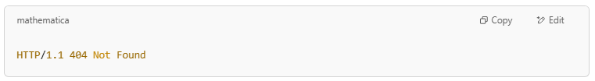
HTTP/1.1 404 Not Found

That means the server couldn’t find the resource you asked for.

